**16-BIT MULTIPLICATION**  
**EXP NO: 7**  
**AIM:**To write an assembly language program to implement 16-bit multiplication using 8085 processor.  
**ALGORITHM:**  
1)      Load the first data in HL pair.   
2)      Move content of HL pair to stack pointer.   
3)      Load the second data in HL pair and move it to DE.   
4)      Make H register as 00H and L register as 00H.   
5)      ADD HL pair and stack pointer.   
6)      Check for carry if carry increment it by 1 else move to next step.   
7)      Then move E to A and perform OR operation with accumulator and register D.  
8)      The value of operation is zero, then store the value else go to step 3.   
**PROGRAM:**  
         LHLD 2050  
         SPHL  
         LHLD 2052  
         XCHG  
         LXI H,0000H  
         LXI B,0000H          
AGAIN: DAD SP  
         JNC START   
         INX B  
         START: DCX D  
         MOV A,E  
         ORA D  
         JNZ AGAIN  
         SHLD 2054  
         MOV L,C  
         MOV H,B  
         SHLD 2056  
         HLT  
**INPUT:**  
  
  
  
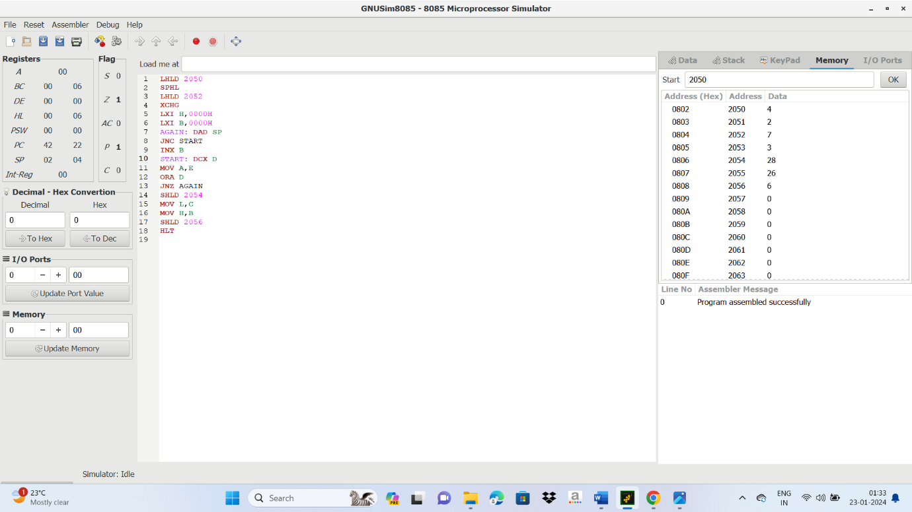

**OUTPUT:**



**RESULT:**

**Thus the program was executed successfully using 8085 simulator**